Title <Arial, Bold, 14 points, single spacing, center>
Main author¹, Second Author², and Third Author³<Arial, regular, 11 points, single spacing, center, presenting author underlined>
¹Affiliation, Town, Country <Arial, Italic, 11 points, single spacing, center>,
²Tampere Microscopy Center, Tampere University, Tampere, Finland,
³Affiliation
Corresponding author: email@affiliation.org <Arial, 10 points, single spacing, center>
The authors are asked to submit their abstracts in Word (.doc or .docx) format no later than March 20th, 2022. The abstracts will be peer reviewed and published as an e-publication, and must therefore follow the format of this template.
The suggested length of the text is between 250 and 500 words, and the maximum length of the abstract is two pages. As the topic of the conference is microscopy, the inclusion of images is encouraged. Refer to figures and tables using the format (Fig. 1) and (Table 1). The name of the presenting author should be underlined. Possible references are to be listed at the end of the abstract using IEEE style and referred to in the text using the corresponding number [1]. <Arial, regular, 11 points, single spacing, Justified>
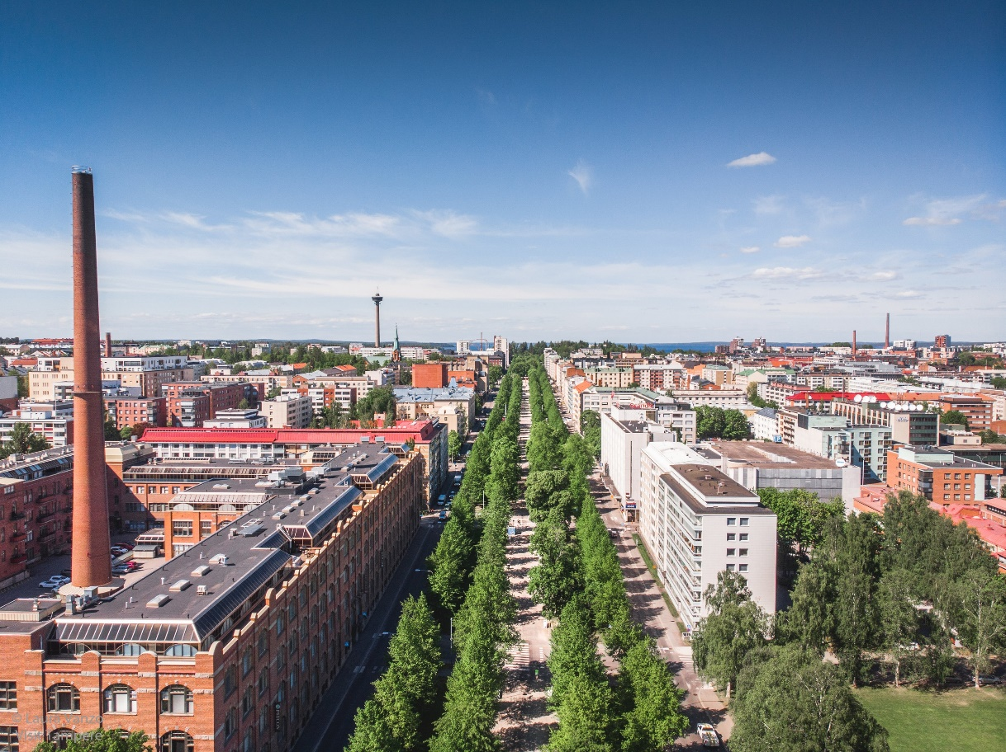
Figure 1 Figures and tables must be captioned. <Arial, italic, 9 points, single spacing, justified>
The abstracts are to be submitted through the web portal at https://events.tuni.fi/scandem2022/abstracts/
If you have any questions, please contact scandem2022@tuni.fi
[1] A. Author, Journal of seven days, 12 (2022) <Arial, regular, 11 points, single spacing >
[2] Ruska E., Knoll M., “Das Elektronenmikroskop“, Z. Phys., 78, 318-339, 1932.

