Example Abstract for the inverse days 2021 in Tampere: One-Page Maximum
Author One^{1,2}, Author Two^{1,2}, Author Three^{1,3}, Author Four², Author Five¹
- Laboratory of Mathematics, Tampere University of Technology, P.O. Box 692, FI-33101 Tampere, Finland.
- Laboratory of Signal Processing, Tampere University of Technology, P.O. Box 553, FI-33101 Tampere, Finland.
- Laboratory of Pervasive Computing, Tampere University of Technology, P.O. Box 553, FI-33101 Tampere, Finland.
This is your abstract text. Please do not change the format of the file. You can include text, figures, and equations as you like. References [1, 2, 3, 4] should be added at the end. Before publishing the abstract some formatting might still be needed to have a consistent look across all abstract, especially if you write in Word. Be registering your abstract, you agree to these changes. No content will be changed without your consent.
Inverse Days is an international meeting of approximately 100 persons and at the same time it is the annual meeting of the Finnish Inverse Problems Society (FIPS). The scope will be inverse problems and their applications. In 2021, it will be organized in Tampere, at the centre campus of Tampere University on 14-16 December.
We aim to organize a hybrid meeting where everything will happen on the Zoom platform, but that there is also activity on the venue. That is, one can attend either in-person or on-line. Registration will be opened in the coming few weeks. The link will be opened first for on-line participation only and after that most likely also for on-site presence after we will better know the possible mobility regulations in December.
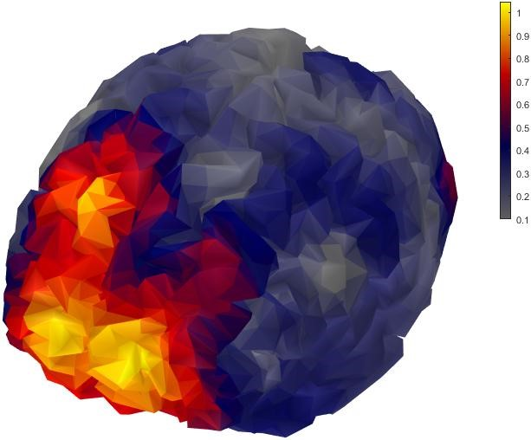
Figure 1: Example illustrations
- Benoit Carry. Density of asteroids. Planetary and Space Science, 73(1):98–118, 2012.
- Josef Durech, Benoit Carry, Marco Delbo, Mikko Kaasalainen, and Matti Viikinkoski. Asteroid models from multiple data sources. Asteroids IV, page 183, 2015.
- Alain Herique and Valerie Ciarletti. A Direct Observation of the Asteroid’s Structure from Deep Interior to Regolith: Two Radars on the AIM Mission. In 47th Lunar and Planetary Science Conference, page 2096, 2016.
- W Kofman and et al. Properties of the 67P/Churyumov-Gerasimenko interior revealed by CONSERT radar. Science, 349(6247), 2015.

Acknowledgements: This work was supported by... AO was partially supported by... AT was partially supported by...

