Abstract title
A. Author¹, C. Coauthor², C.A. Coauthor¹
¹Faculty of Medicine & Health Technology, Tampere University, Finland
²Faculty of Engineering and Natural Sciences, Tampere University, Finland

INTRODUCTION: Please submit your original research as an abstract for poster and/or oral presentation at ScSB2025 by 15 January 2025.
Conference abstracts will be published online at the conference website and will also be available in the conference abstract booklet. It is therefore MANDATORY that the abstract layout adheres to this template. Please do not change fonts, font size, line spacing, margins or any other formatting elements on this abstract template when preparing your abstract. Simply just replace the template text and abstract instructions with your own text and figures. For references, please use the indicated reference style [1-2]. Including a hyperlink to your departmental website in the author affiliation is optional.
Please submit your abstract as a word document to the abstract submission system at https://events.tuni.fi/scsb2025/call-for-papers/. The file name should be the last name of the presenting author. The abstract must not exceed one page in length and 5 MB in size.
METHODS: Briefly describe your methods here.

RESULTS: Use the results section to shortly describe the main findings of your research.
Adding figures can be a useful way to present your results in a short and simple manner (Fig. 1). However, make sure all included figures have sufficient resolution for printing (min. 300 dpi). Tables are accepted as well.
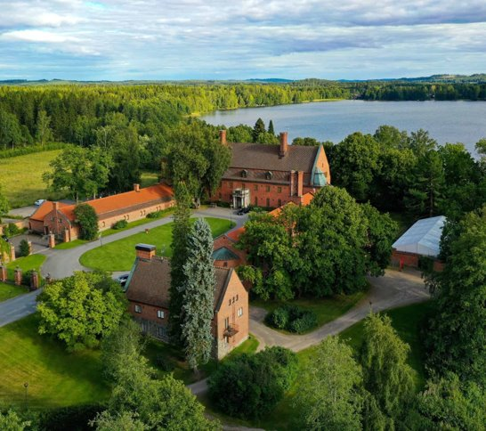
Fig. 1: You can also use figures and illustrations in your abstract to reduce the number of words needed to explain your results.
DISCUSSION & CONCLUSIONS: Briefly discuss your main findings and how they compare to the existing research literature in the field. Also, summarise the most important conclusions that can be drawn from your results.
REFERENCES: ¹J.T. Koivisto et al. (2019) ACS Appl. Mater. Interfaces, 11: 20589-20602. ²A. Ressler et al. (2024) Ceram. Int., 50:27403-27415.
ACKNOWLEDGEMENTS: Do not forget to give credit to those who helped you perform the experiments or funded your research.
Make sure your abstract does not exceed one page!

