ILCEC2025’s Abstract Title is in Bold (Times New Roman 14 pt, Centered)

Presenting Author¹, Second Author², Corresponding Author^{1*} (Times New Roman 12 pt, centered)
1 First affiliation with address, Country (Times New Roman 10 pt Italic, centered)
2 Second affiliation with address, Country (Times New Roman 10 pt Italic, centered)
*Corresponding author e-mail: (Times New Roman 10 pt, centered)
Please use this template for writing the abstract for ILCEC2025. The paper size is A4 (21.0 x 29.7 cm) with top/bottom margins of 2.5 cm and left/right margins of 2.0 cm. The maximum length of the abstract is one page. The deadline for submitting the abstract is Saturday 15 February 2025, 23.59 Finnish time (UTC+2), only via https://www.lyyti.fi/reg/ilcec2025cfp.
Choose the proper style from the style menu on top. For instance, the main text is to be written in “Normal style”: Times New Roman 12, single spacing, justified and an indentation of 1 cm at the first line of the following paragraphs in case of adjacent paragraphs.

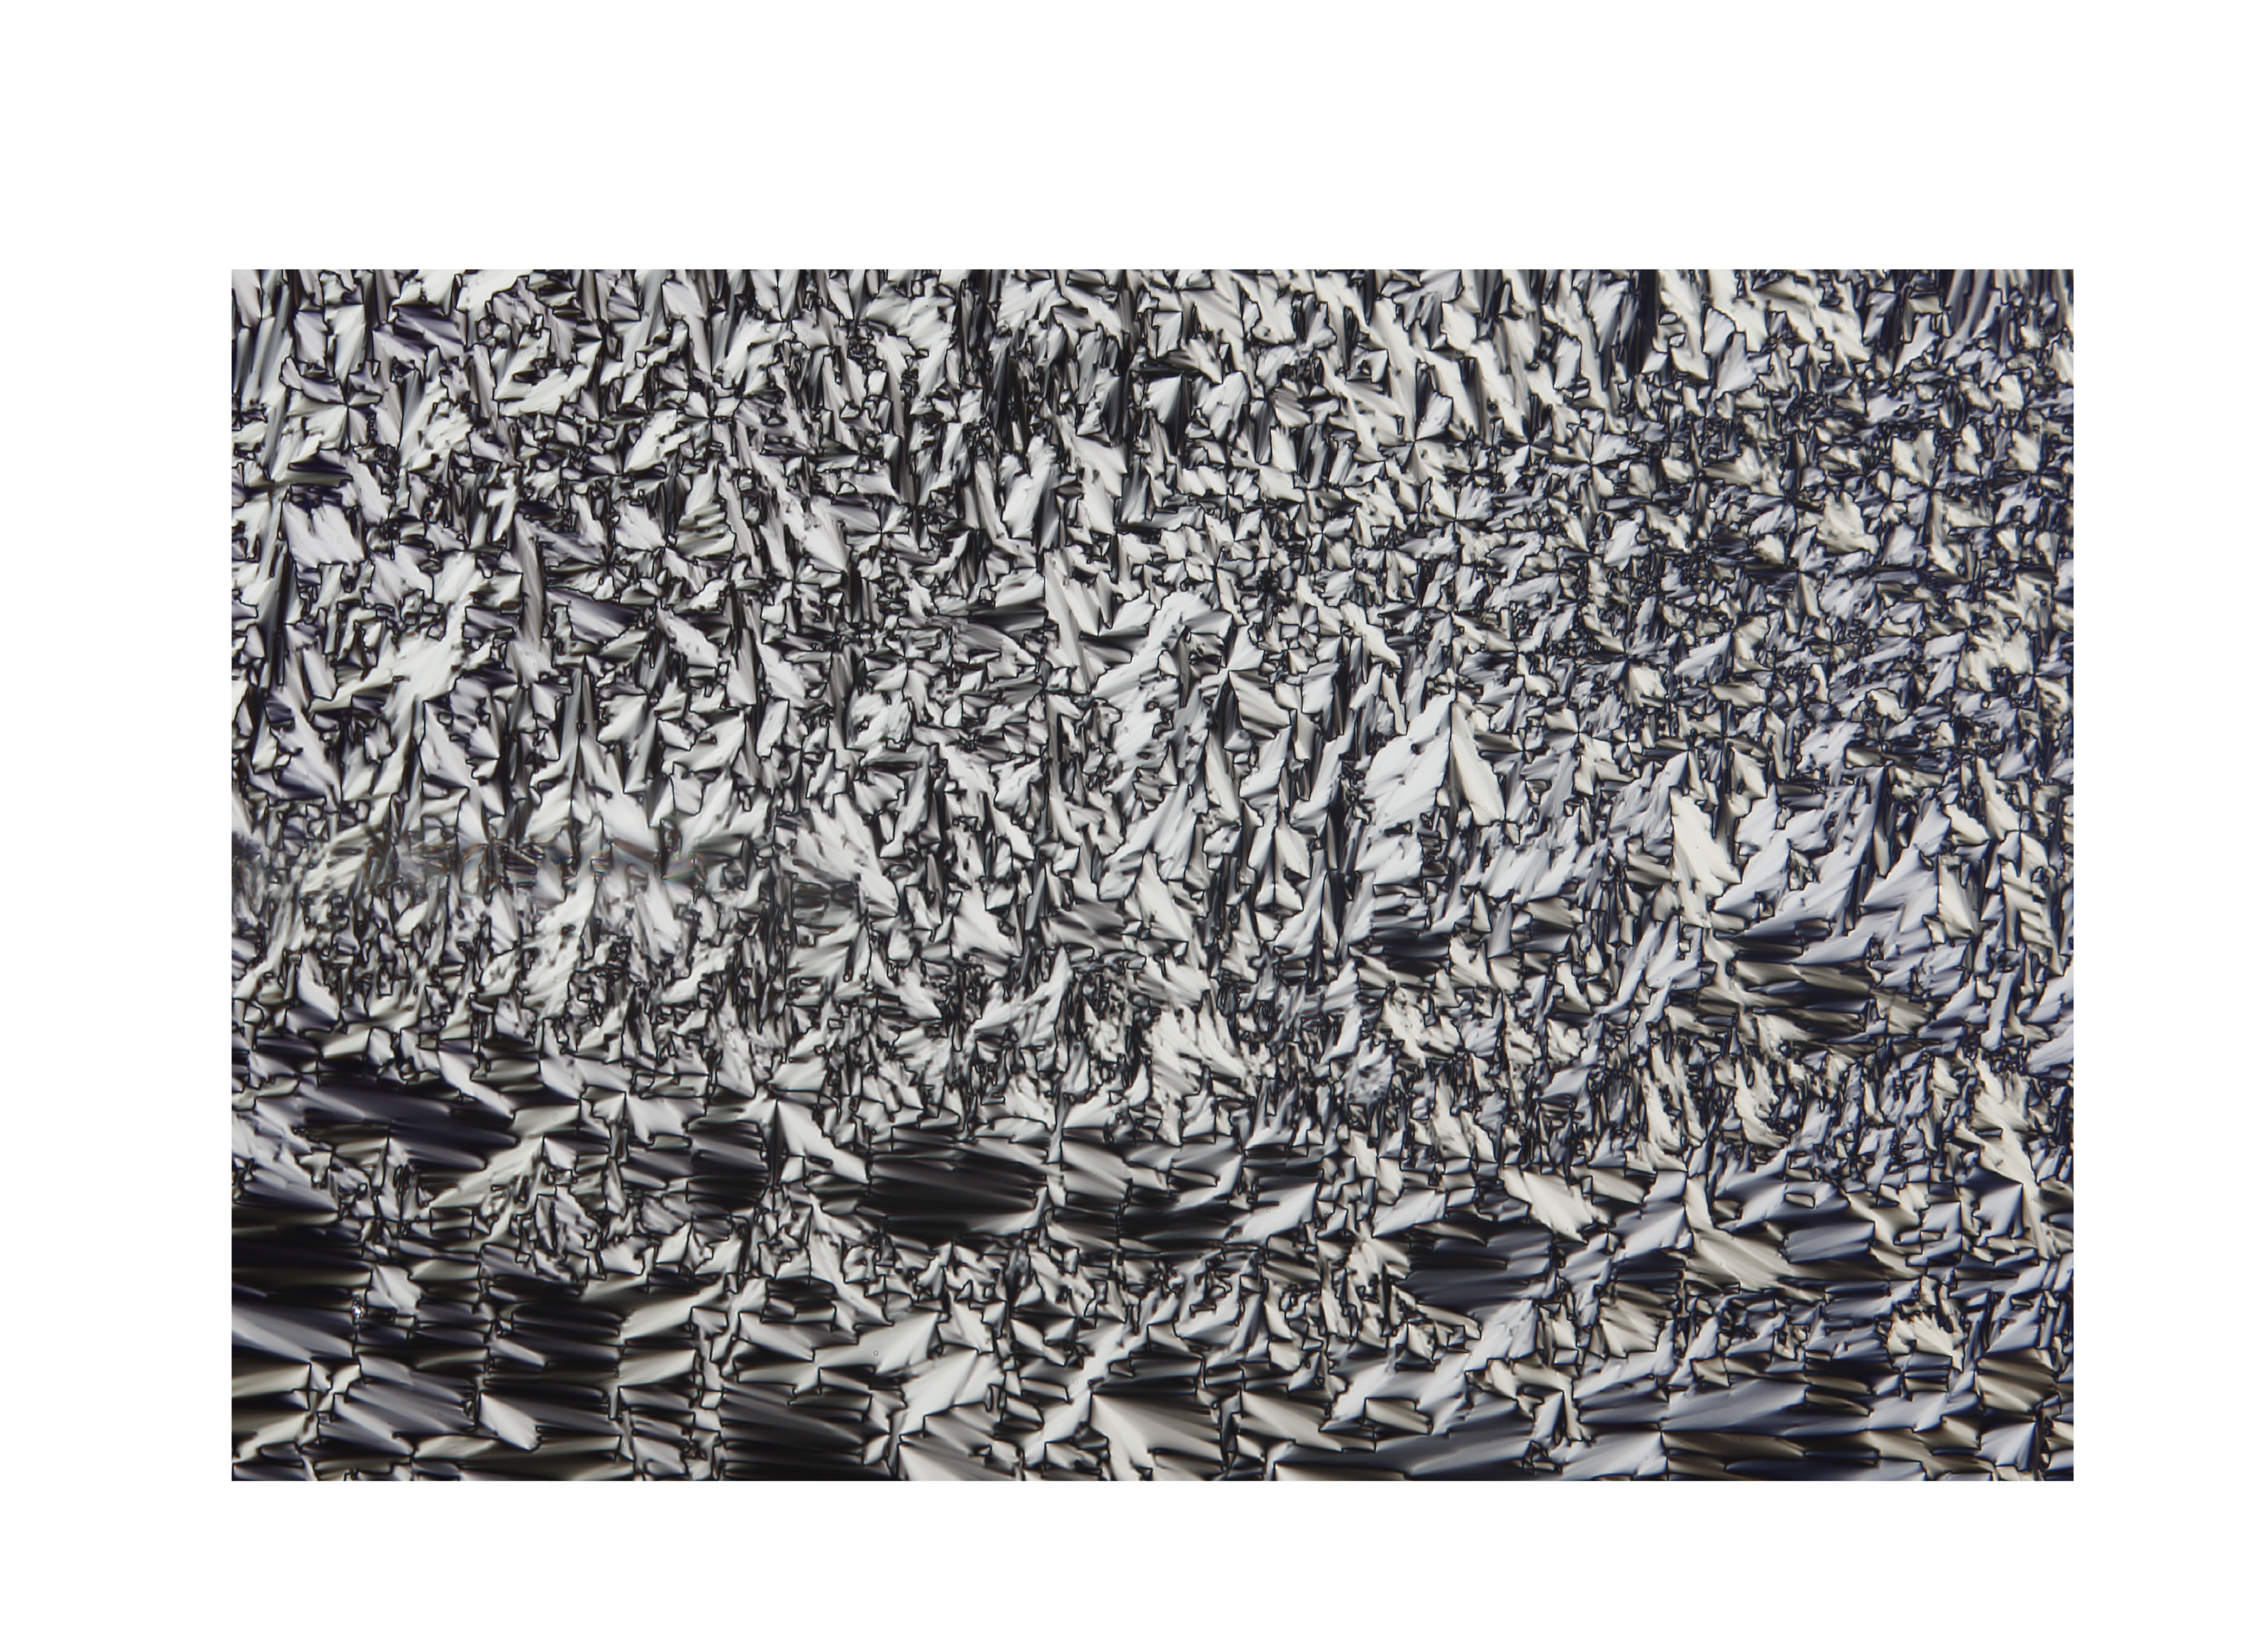
Figure 1. Please include figures, formulas and schemes in line with the main text. Color images can be used. Make sure that the images are clearly visible!
Please do not modify the styles used in this template, as the book of abstracts will look nice and uniform with every abstract written following the same style. Cite the references in line as [1] in the middle of a sentence, and at the end, place the citation preceding a full stop [1,2].

Please save your document in PDF-format before submitting (File, Save As, Select PDF in the “Save as type”-section) since doc and docx files are not accepted by our paper submission system in order to avoid compatibility issues.

Good luck! In case you have any questions or problems, please contact the organizers of ILCEC2025 via ilcec2025@tuni.fi.
- A. U. Thor, C. O. L. League, and P. Rof, Journal, Year, Volume, starting page. (Times New Roman 10 pt)
- A. Writer and A. Scholar, Book title, Year, Publisher. (Times New Roman 10 pt)

