Title <Arial, Bold, 14 points, single spacing, center>
Main author¹, Second Author², and Third Author³ <Arial, regular, 11 points, single spacing, center, presenting author underlined>
¹Affiliation, Town, Country,
²Affiliation,
³Affiliation <Arial, Italic, 11 points, single spacing, center>
Corresponding author: email@affiliation.org <Arial, 10 points, single spacing, center>

The authors are asked to submit their abstracts in Word (.doc or .docx) format no later than 3 March 2024. The abstracts will be peer-reviewed and published in the open access e-publication and must therefore follow the format of this template.
The suggested length of the text is between 250 and 500 words, and the maximum length of the abstract is two pages. The name of the presenting author should be underlined. Refer to figures and tables using the format (Fig. 1) and (Table 1). Possible references are to be listed at the end of the abstract and referred in the text using the corresponding number [1]. <Arial, regular, 11 points, single spacing, Justified>
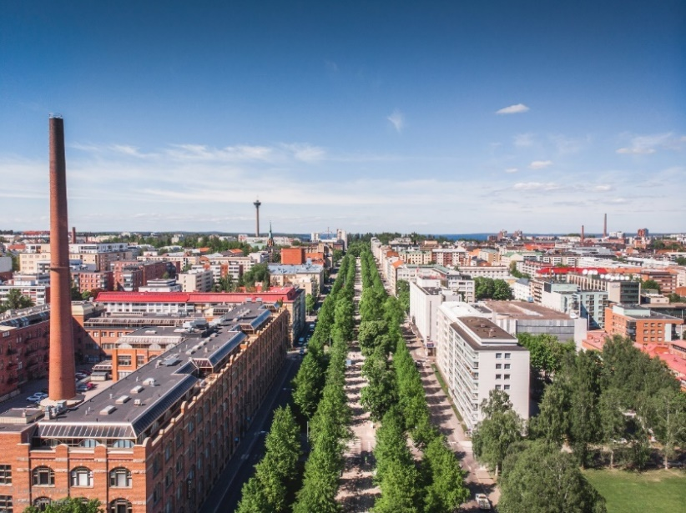
Figure 1 Figures and tables must be captioned. <Arial, italic, 9 points, single spacing, justified>
The abstracts are to be submitted through the web portal at https://events.tuni.fi/icbm15/abstracts/
If you have any questions, please contact icbm15@tuni.fi
[1] A. Author, Journal of Seven Days 12 (2024) 12−16.
[2] B. Author, Book of Magnetism, 2nd edition, Publisher (2024). <Arial, regular, 11 points, single spacing >

